**Creating Relationships**

In this demo, you verify the relationships that were created automatically when you imported data and add new relationships between different tables. A relationship is a connection between two tables that establishes how the data in those tables should be correlated. For example, the DimProduct table and the DimProductSubcategory table have a relationship since each product belongs to a subcategory.

## **Reviewing existing relationships and add new relationships**

When you imported data by using Get Data, you got seven tables from the AdventureWorksDW database. Generally, when you import data from a relational source, existing relationships are automatically imported together with the data. For Get Data to automatically create relationships in the data model, there must be relationships between tables at the data source.

Before you proceed with authoring your model, you should verify those relationships between tables were created properly. For this tutorial, you also add three new relationships.

#### **Reviewing existing relationships**

1. Click the **Model** menu > **Model View** > **Diagram View**.

The model designer now appears in Diagram View, a graphical format displaying all the tables you imported with lines between them. The lines between tables indicate the relationships that were automatically created when you imported the data.

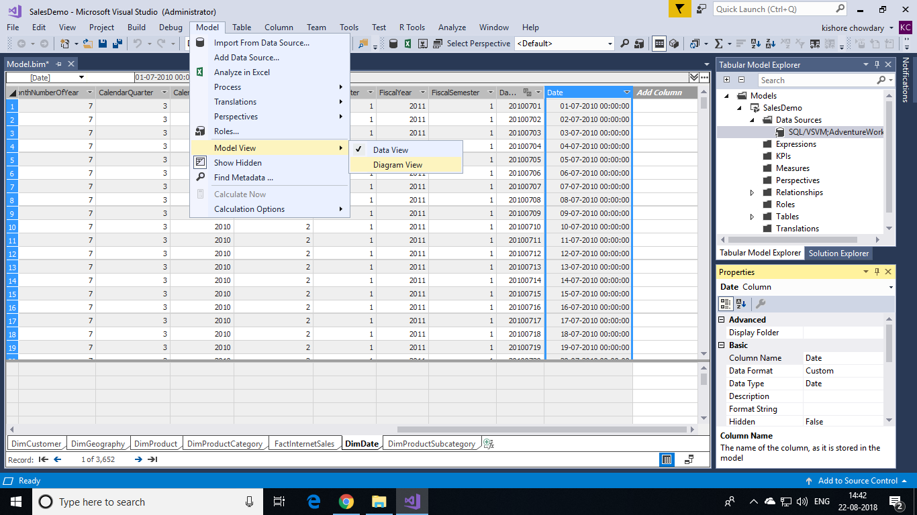

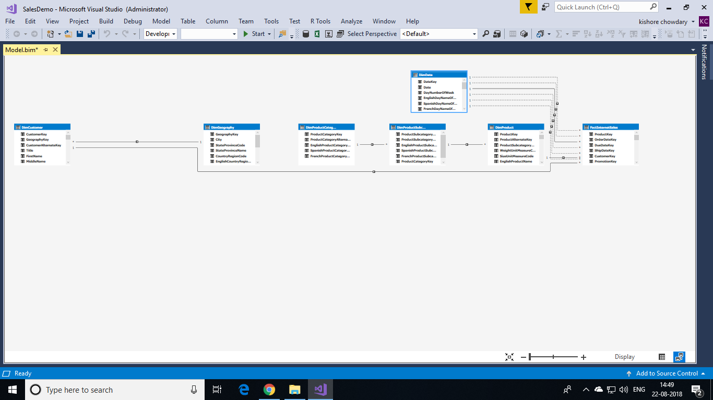

If you don't see any relationships between tables, it likely means there are no relationships between those tables at the data source.

Include as many of the tables as possible by using minimap controls in the lower-right corner of the model designer. You can also click and drag tables to different locations, bringing tables closer together, or putting them in a particular order. Moving tables does not affect the relationships between the tables. To view all the columns in a particular table, click and drag on a table edge to expand or make it smaller.

1. Click the solid line between the **DimCustomer** table and the **DimGeography** table. The solid line between these two tables shows this relationship is active, that is, it is used by default when calculating DAX formulas.

Notice the **GeographyKey** column in the **DimCustomer** table and the **GeographyKey** column in the **DimGeography** table now both each appear within a box. These columns are used in the relationship. The relationship’s properties now also appear in the **Properties** window.

1. Verify the following relationships were created when each of the tables were imported from the AdventureWorksDW database:

| **Active** | **Table** | **Related Lookup Table** |
| --- | --- | --- |
| **Yes** | **DimCustomer [GeographyKey]** | **DimGeography [GeographyKey]** |
| **Yes** | **DimProduct [ProductSubcategoryKey]** | **DimProductSubcategory [ProductSubcategoryKey]** |
| **Yes** | **DimProductSubcategory [ProductCategoryKey]** | **DimProductCategory [ProductCategoryKey]** |
| **Yes** | **FactInternetSales [CustomerKey]** | **DimCustomer [CustomerKey]** |
| **Yes** | **FactInternetSales [ProductKey]** | **DimProduct [ProductKey]** |

If any of the relationships are missing, verify your model includes the following tables: DimCustomer, DimDate, DimGeography, DimProduct, DimProductCategory, DimProductSubcategory, and FactInternetSales. If tables from the same datasource connection are imported at separate times, any relationships between those tables are not be created and must be created manually. If no relationships appear, it means there are no relationships at the datasource. You can create them manually in the data model.

#### **Adding new relationships between tables**

1. In the model designer, in the **FactInternetSales** table, click, and hold on the **OrderDate** column, then drag the cursor to the **Date** column in the **DimDate** table, and then release. A solid line appears showing you have created an active relationship between the **OrderDate** column in the **Internet Sales** table, and the **Date** column in the **Date** table.

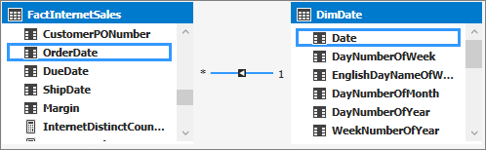

1. In the **FactInternetSales** table, click and hold on the **DueDate** column, then drag the cursor to the **Date** column in the **DimDate** table, and then release.

A dotted line appears showing you have created an inactive relationship between the **DueDate** column in the **FactInternetSales** table, and the **Date** column in the **DimDate** table. You can have multiple relationships between tables, but only one relationship can be active at a time. Inactive relationships can be made active to perform special aggregations in custom DAX expressions.

1. Finally, create one more relationship. In the **FactInternetSales** table, click and hold on the **ShipDate** column, then drag the cursor to the **Date** column in the **DimDate** table, and then release.

